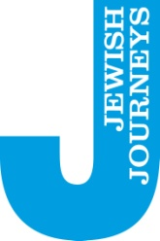

14th – 18th May 2023: Alsace – Lorraine
The Politics of ‘We’
Jews in the eye of a European storm
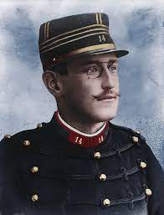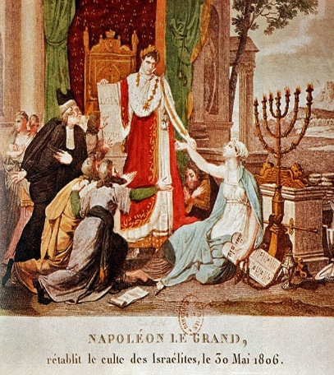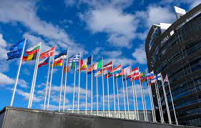
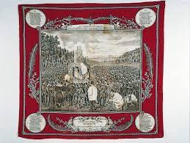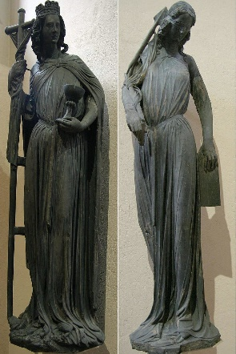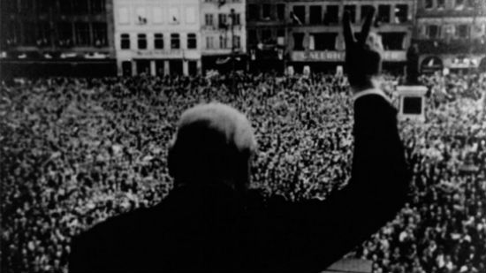

Not for the first time on Jewish Journeys, we aim headlong into the eye of one of the stormiest debates of Jewish history: Who are? What are the politics of the term ‘us’?
Immediately after the war, decades before other UK politicians would challenge the idea, none other than Winston Churchill stood in Place Kléber, in central Strasbourg, and declared “We must build a United States of Europe”. That was a uncomfortable question for the Jews that day, since in 1945 linking their destiny to that of Europe must have seemed quite a stretch. But it offers a good opening to our journey, offering themes of optimism and unity. Maybe it is also worth saying that this trip concludes on the memorial slopes of Verdun where, just decades beforehand, Jews saw their identities bitterly tested in a different world war, looking out of trenches and seeing their brethren on the other side.
Citizen? Jew? European? …. Terms that all characterize the politics of ‘us’.
But more broadly, in the beautiful and rich landscape of northern France, we turn our attention to some of the oldest Jewish communities in Europe, to the very origins of ‘Western Ashkenaz’ and the essence of the European Jewish story.
In every sense, on this JJ, we are ‘visiting’ the story of Jews of Europe, on the border of France and Germany, in communities touched by all the highs and lows of the European experience, from lowly achievements in the fields of trade to the cultural richness of the Renaissance. At its high point we encounter the most influential thinker of the premodern period, Yosel of Rosenheim, and Cerf Baer, described by some as the very first Jewish ‘citizen’ of Europe. And here too we meet the Dreyfus family whose famous ‘son’, Alfred, came to characterize the modern world in much harsher ways.
Ironic though it may be to say, especially given all the above, this is a JJ that also investigates the question of optimism! All of history is behind us and new history is being created every day. The Jews of Strasbourg and Metz are building themselves afresh in times no less fraught, with a clear sense that however we understand who ‘us’ is,, there is no future without optimism.

Sunday May 14th Strasbourg, ‘Europe’ and the Jews
We begin in Strasbourg, a small city that embodies a big idea - that of ‘Europe’. Recent British political controversies notwithstanding, there was and remains an idea of a region of the world comprising many ethnic and linguistic groups, that carries something in common. What that thing is, is where we begin!
And as Jews, having been witnesses to all the histories of this continent for over two thousand years, we have much to say about what Europe promised, both in the distant past (the Holy Roman Empire 800CE?) and more recently, in the twentieth century which some argue, metaphorically speaking, is a century that is very much still going.
14:30 Meet at our hotel, introductions
Depart by bus – sites as entry points to our journeys:
- Passerelle des Deux Rives
- Old University of Strasbourg
- Place Kleber
- Council of Europe
- European Parliament
18:00 Dinner (provided tbc)
Overnight Hotel Strasbourg IBIS Centre Historique

Monday 15th Strasbourg and its Jewish story
It is true that Strasbourg is a city defined by its border with Germany, and from 1870 becoming part of that country, but for Jews the story is emblematic of all that was good and bad in the medieval world. Furthermore, it like Metz, is defined by a different border, that which traverses medieval to modern. It was here, among the Jews of Northeastern France that the high drama of Enlightenment and French Revolution played itself out for Jews. Walking its beautiful streets, close to its beautiful streams and canals, we follow ideological, religious and philosophical pathways that led from the past to a challenging new present.

9:30 Walking tour sites of Jewish Strasbourg: Place de la Republique; Passerelle des Juifs; rue des Juifs; the Jewish Quarter, rue Brulee, Mikveh, Notre Dame Cathedral; Place Guttenberg
13:00 Break, lunch
14.30 Visit European Parliament, Strasbourg
16:00 Bischeim: Walking tour continued: The life and times of Cerf Berr, Rabbi David Siztheim and the entrance to the modern world
18:30 Finish, free time
Overnight Hotel Strasbourg IBIS Centre Historique

Tuesday 16th May Jews of rural Alsace
Departing Strasbourg, our journey takes us to an oft-overlooked area of European Jewish life, that of rural Alsace – once boasting hundreds of small villages with Jewish communities. The combination of modernization, demography shifts and the legacy of the Holocaust, means that few Jews are still to be found in the villages, even though a significant legacy of material heritage remains. A day in several acts: changing direction and focus entirely, we tack to the micro story of Jews in this important region for Jewish history, their lives and how they recorded them.
08:30 Depart on bus:
9:30 Pfaffenhoffen (synagogue)
10:30 Drive to Reischoffen
12:30 Break, Lunch in Haggenau
14:00 Jewish Museum of Alsace, Bouxwiller
16:00 Drive to Metz
18.00 Check in hotel
Overnight, Novotel Centre, Metz

Wednesday 17th May Metz
We wake up in the region of Lorraine, where European Jewish history has its deepest roots. Situated at the confluence of the Moselle and the Seille rivers, Metz shares its legacy and significance with the Rhineland Jewish communities, whose history, culture and traditions defined early Ashkenaz. We encounter it across all the periods, but most significantly in the modern era when the Jews of Metz faced all the dilemmas of newfound hyphenated French / German Jewish identity, from Revolution to the dramas of Franco Prussian War. Most significantly, we will connect with the local Jewish community whose centre in the historic synagogue became an emblem of post Holocaust reconstruction.
09:00 Walking tour of the Jewish sites of Metz: En Jurue and the medieval community; Port d’amands and the remarkable story of Raphael Levy; Cathedral of Metz; Academie Nationale de Metz (En Nexirue) and the Jews.
13:00 Break, lunch
14.30 Drive to
16:00 Visit Synagogue and meet with Chief Rabbi of Lorraine
Evening Dinner (provided tbc)

Thursday 18th May Verdun
From the more local stories of the Jews of Alsace Lorraine, we finish by revisiting the central symbol of this journey – ‘Europe’ -expressed in the sites of Verdun. Here, on the preserved battlefields and constructed memorials, lies the memory of where Europe almost disintegrated just over a hundred years ago. For Jews there is added poignancy, as Jews fought in all uniforms alongside fellow citizens from their respective countries, oblivious to the fact that in the next European upheaval they would all be as one.
On one level it is quite a stark place to finish this journey, nonetheless the challenge is to remember the luxury of being able to look forward, all the wiser for that which has preceded us.
09:00 Depart Metz by bus
10.00 Verdun: tour key battlefield sites and memorials (Ossuary; Jewish Memorial, Fort Douaumont; Fleury-devant-Douaumont
12:00 Monument for Peace; Synagogue, Verdun
13:00 Finish, lunch
15:00 Depart for Luxembourg airport
17:00 Arrive Luxemburg airport

