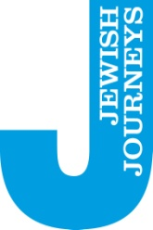

The Great Jewish Migration
Latvia: Riga; Kuldiga; Liepaja (Libau) + Lithuania: Palanga; Kretinga; Klaipeda (Memel)
28th May – 1st June 2026
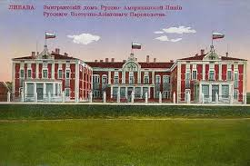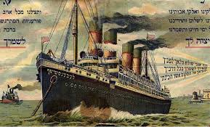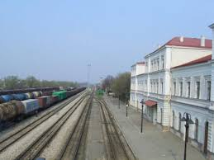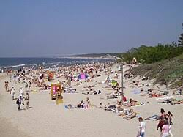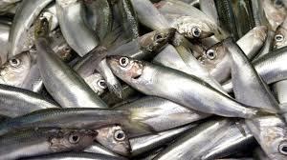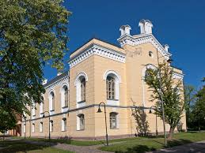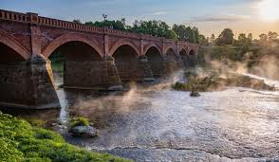
If ever there was a Jewish Journey that symbolically or literally tells ALL of our stories, this is it! For the fifty year period from the end of the 19th century onwards, some three million Jews emigrated from Eastern Europe to the New World - the largest proportionate migration of Jews since the expulsion from Spain. Of that number, easily twenty percent left through the ports on the Baltic coast of Riga, Liepaja / Libau and Memel / Klaipeda.
This is a journey about the story of Jewish migration – not just how they left, but why .. and why not? It is the story of the journeys taken by Jews from towns and villages across the northern parts of the Russian Empire along the roads and through the railway stations before reaching the ports on the Baltic coast. And crucially, it is also the story of Jews in London, Manchester, Glasgow and all the way across the Atlantic looking backwards sometimes with nostalgic yearning, to the world they had left behind.
And caught up in this rich story are all manner of fascinating side stories that tell of the relationship of Jews and the Baltic coast in other ways: the fascinating (!) and untold story of Jews and the herring industry; no less significant, the emergence of a new beach and leisure culture for Jews in Palanga (the Bournemouth? Blackpool? of the Baltics!)
And finally, maybe obviously, how do ‘we’, as the grandchildren of those migrants, look back on the migration story as part of our story.

THE DETAILS:

Price will be £905 pp sharing a double/twin room or £1035 for single occupancy.
The price includes

- All transport during the trip throughout Latvia and Lithuania but excludes your international return travel which is not included and is your responsibility.

- 4 nights hotel accommodation on a Bed and Breakfast basis, 3 evening meals, all entry fees and local co-ordinator and as usual will be led by Jeremy Leigh throughout.

- It does not include other meals or tips to local guides or drivers. We suggest that you budget 6 euros (or equivalent currency) per day for those tips which will be collected in cash.

HOTELS:

RIGA (28-29/05/2026; 1 night): Wellton Centrum Hotel & SPA 4*
KULDIGA (29-30/05/2026; 1 night): Jēkaba Sēta Hotel 3*
LIEPAJA (30-31/05/2026; 1 night): Amrita Hotel 4*
KLAIPEDA (31/05-01/06/2026; 1 night): Amberton Hotel Klaipeda 4*

Trip is based on a minimum of 25 participants. A non-refundable deposit of £200 per person is payable with your booking form. Balance of payment will be due by 28th February 2026.

To book please contact Marcel Manson at West End Travel. Tel: 07712 290520 marcel.manson@westendtravel.co.uk

PLEASE DO NOT BOOK YOUR TRAVEL UNTIL THE TRIP AND YOUR PLACE ON IT ARE CONFIRMED.

